**IT21206078_DL-LAB-04**

07. In the below given cell, shape of the boxes.eval() is (1783,4). Why are there 1783 boxes? Explain the reason for it.

**the threshold is set to 0.5, so only boxes with a confidence score of at least 0.5 are kept. The shape of the boxes tensor is (19, 19, 5, 4), so there are a total of 19 * 19 * 5 = 1783 boxes. However, after applying the threshold, only the boxes with a confidence score of at least 0.5 are kept, which results in a shape of (1783, 4).**

**The maximum number of boxes - 1783**

**The minimum number of boxes - 0**

What is the maximum number and minimum number you can get for that? Write these answers in a word file.

* + Change the values like mean and stddev in lines 2 and 4 as well as threshold value in line 5 and observe the different values you get for the boxes.eval().shape.

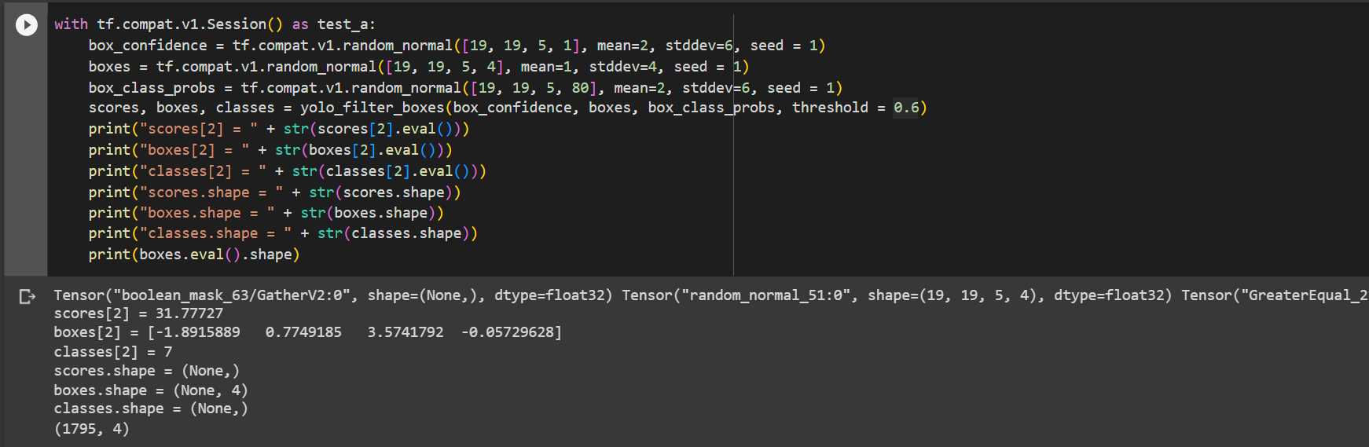

08. yolo_anchors.txt contains 10 values. They can be considered as height and width of 5 anchor boxes. What is the advantage of using such anchor boxes? What was the method used to determine the sizes of these anchor boxes? Give the answers to these questions in the word file.

* **Enhanced object recognition**
* **increases object localization accuracy**
* **Capture both tiny and large items successfully in the same grid cell.**

9. Upload a new traffic image to images and edit the code as needed to detect vehicles in that image

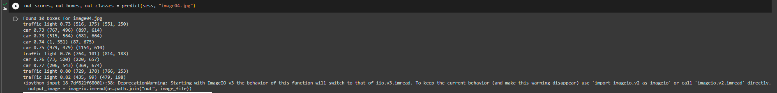

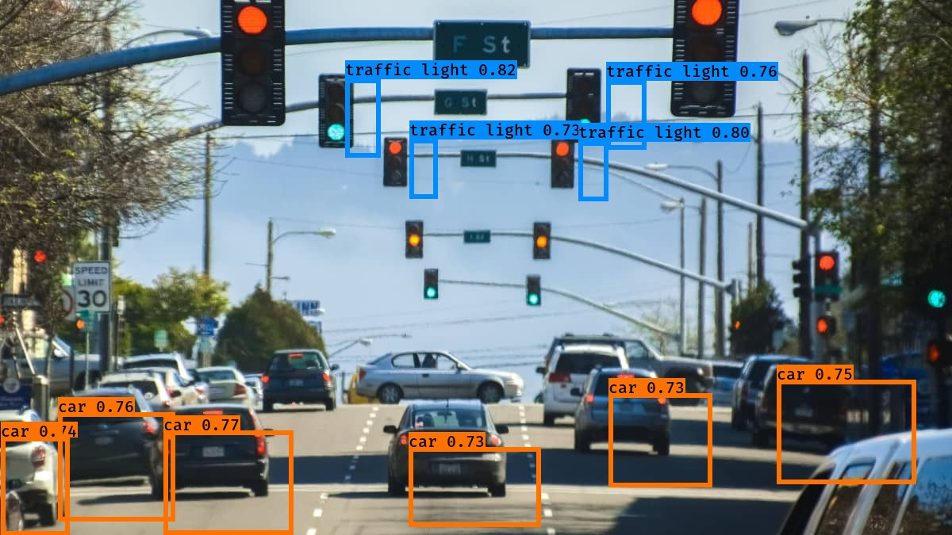

10. Download the output images zip file from the google drive and observe the bounding boxes in the autonomous driving dataset (i.e., 21 images from 0100.jpg to 0120.jpg). Select 2 images from these 21 images and,

* + Write what you observe regarding correctly detected objects, incorrectly detected objects, undetected objects and incorrect bounding boxes in the word file.
  + Include these output 2 images as well as the original 2 images in the word file.

**Nearby Vehicles and color lights properly detected. But some cars and lights in faraway not detected.**

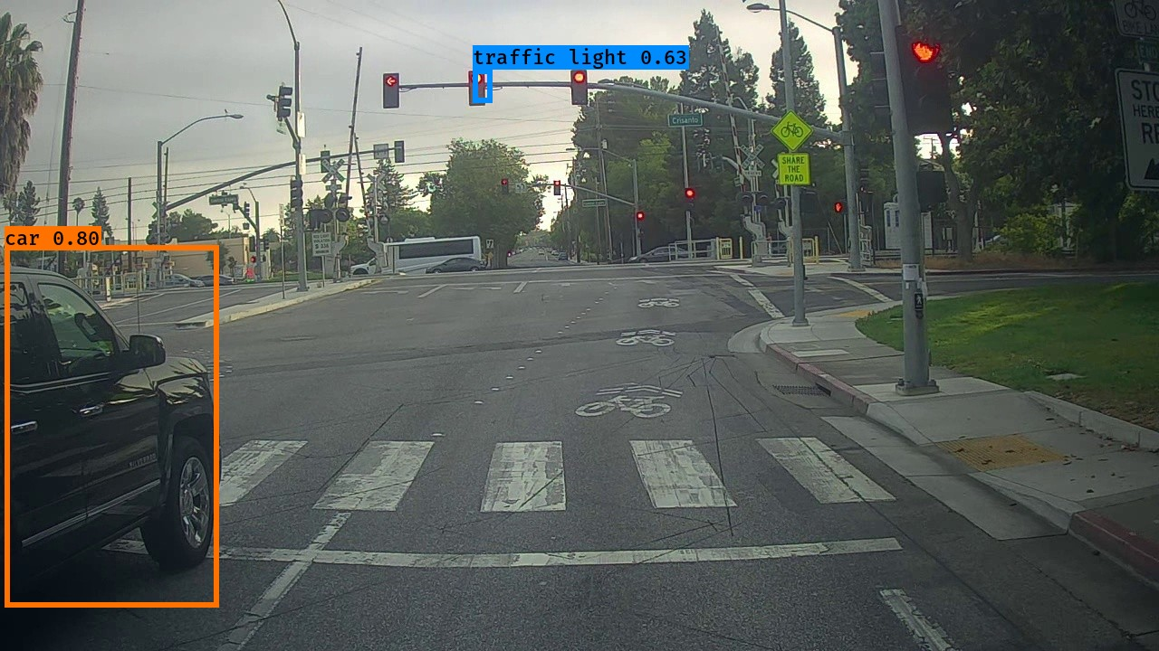

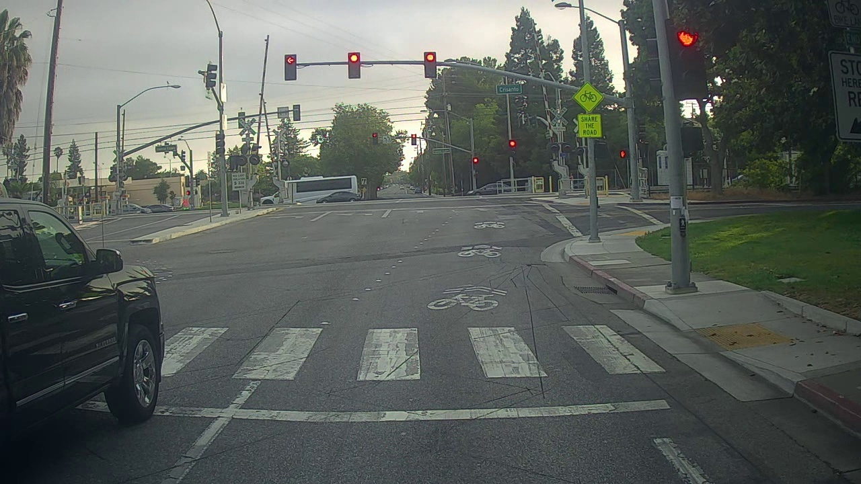

**Identified the car and the fire hyd properly. But the color lights and other vehicles have not been detected.**

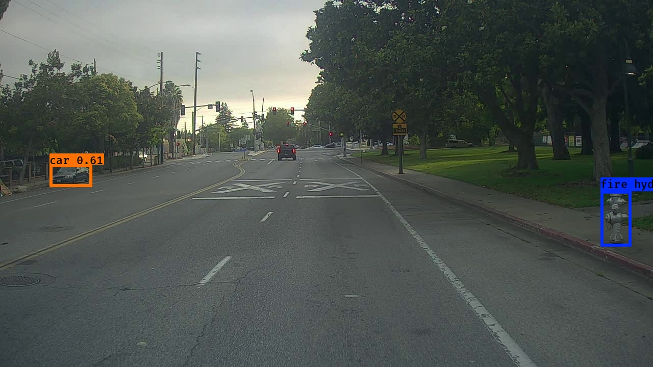

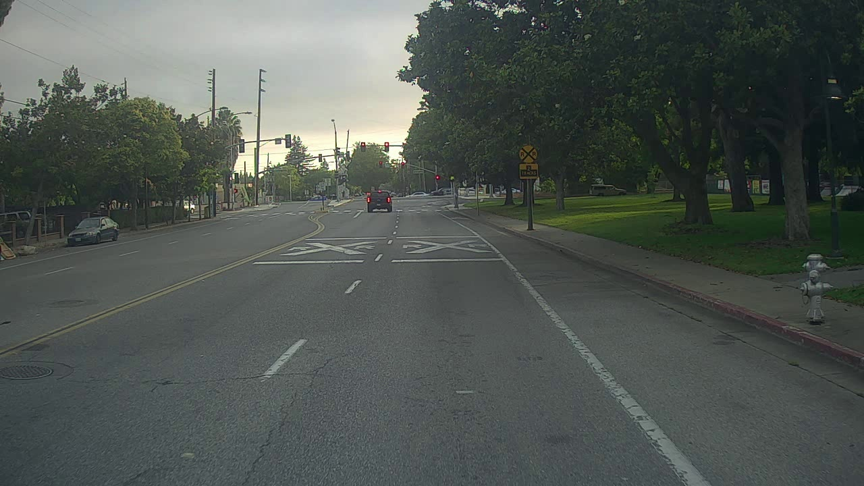

11. Adjusting parameters like max_boxes, score_threshold, and iou_threshold of the yolo_eval function can potentially address the limitations you noticed in step 10.

* Change the max_boxes [integer value] to a different value but use the original values for other 2 variables. Rerun the required cells to get the output images for the autonomous driving dataset. Observe if this result in improvement compared to step 10 for the same two images. If there are any improvements, write them in the word file. Include the new 2 output images in the word file.

**Increased and decreased the value of max_boxes value, but couldn’t find any improvements.**

* Change the score_threshold [value between 0-1] to a different value but use the original values for other 2 variables. Rerun the required cells to get the output images for the autonomous driving dataset. Observe if this result in improvement compared to step 10 for the same two images. If there are any improvements, write them in the word file. Include the new 2 output images in the word file.

**Change the value of Secure_threshold=0.15 and it could detected faraway vehicles and color lights**



* Change the iou_threshold [value between 0-1] to a different value but use the original values for other 2 variables. Rerun the required cells to get the output images for the autonomous driving dataset. Observe if this result in improvement compared to step 10 for the same two images. If there are any improvements, write them in the word file. Include the new 2 output images in the word file.

**Increased and decreased the value of Iou_threshold. But couldn’t find any improvements.**